CREATE JAVA APPLICATION

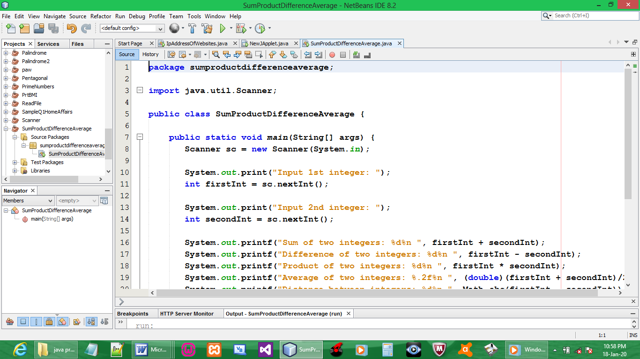
CODE:

package sumproductdifferenceaverage;

import java.util.Scanner;

public class SumProductDifferenceAverage {

public static void main(String[] args) {
Scanner sc = new Scanner(System.in);

System.out.print("Input 1st integer: ");
int firstInt = sc.nextInt();

System.out.print("Input 2nd integer: ");
int secondInt = sc.nextInt();

System.out.printf("Sum of two integers: %d%n ", firstInt + secondInt);
System.out.printf("Difference of two integers: %d%n ", firstInt - secondInt);
System.out.printf("Product of two integers: %d%n ", firstInt * secondInt);
System.out.printf("Average of two integers: %.2f%n ", (double)(firstInt + secondInt)/2);
System.out.printf("Distance between integers: %d%n ", Math.abs(firstInt - secondInt));
System.out.printf("Max integer: %d%n ", Math.max(firstInt, secondInt));
System.out.printf("Min integer: %d%n ", Math.min(firstInt, secondInt));
}
}

OUTPUT:

